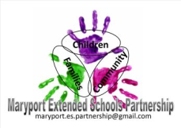
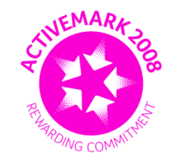
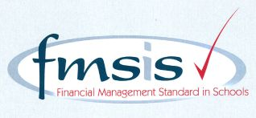
Big enough for opportunity
Small enough to care

CROSSCANONBY ST JOHN'S CofE PRIMARY SCHOOL

Mrs A Pitcher Telephone: 01900 812326
Executive Headteacher Fax: 01900 816420
Garborough Close e-mail: head@crosscanonby.cumbria.sch.uk
Crosby www.crosscanonby.cumbria.sch.uk

MARYPORT

Cumbria CA15 6RX

Dear Parents/Guardians,

For your information we have outlined below some of the topics that will be covered this term in Year 6. We have already made a good start to our studies and we feel sure that you will make every effort to assist and encourage your child as this term progresses.

ENGLISH:

- Classic Literature – ‘Shakespeare’
- Drama
- Balanced arguments
- Newspaper articles
- Poetry – performance verse

- SPaG (Spelling, Grammar and Punctuation):

- Dashes for parenthesis
- Modal verbs
- Semi-colons
- Synonyms
- Using brackets

SCIENCE:

- Sound
- Electricity

MATHEMATICS:

- Fractions
- Converting units of measure
- Ratio
- Algebra
- Decimals and Percentages
- Area, Perimeter and Volume
- Statistics

HISTORY:

- When and why did we create the British Empire?

GEOGRAPHY:

- Why is climate change such an important topic?

ART/DESIGN AND TECHNOLOGY

- Sculpture - Working with clay
Cooking and Nutrition – ‘Can we grow our own salad?’

RE:
- How can God bring freedom and justice?
Understanding Christianity: PEOPLE OF GOD
- How is the resurrection portrayed as central to Christian beliefs?

PE:
- Dance
- Gymnastics

COMPUTING:

- Spreadsheets (Information Technology)
- Understanding Binary (Computer Science)

MUSIC
- Peripatetic Music Teacher in school weekly - Music and Rhythms From Around The World

PSHE

- Dreams and goals
- Healthy Me

FRENCH

- Food and Drink
- Healthy Lifestyles

