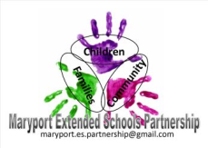
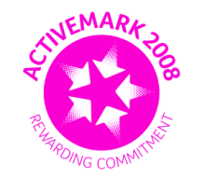
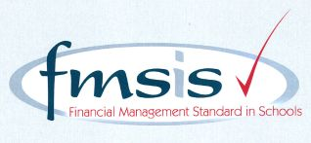
Big enough for opportunity
Small enough to care

CROSSCANONBY ST JOHN'S CofE PRIMARY SCHOOL

Mrs A Pitcher Telephone: 01900 812326
Executive Headteacher Fax: 01900 816420
Garborough Close e-mail: head@crosscanonby.cumbria.sch.uk
Crosby www.crosscanonby.cumbria.sch.uk

MARYPORT

Cumbria CA15 6RX

Dear Parents/Guardians,

For your information we have outlined below some of the topics that will be covered this term in Year 6. We have already made a good start to our studies and we feel sure that you will make every effort to assist and encourage your child as this term progresses.

ENGLISH:

- Descriptive writing
- Adventure stories
- Figurative language
- Symbolism
- Diary writing
- Newspaper reports
- Job advertisements

- SPaG (Spelling, Grammar and Punctuation):

- Using commas for meaning
- Using the passive voice
- Formal and informal speech
- Dashes
- Punctuating direct speech
- Adverbs

SCIENCE:

- Sound
- Electricity

MATHEMATICS:

- Number and place value
- Powers of 10
- Addition, Subtraction, Multiplication and Division
- Common factors and multiples
- Rules of divisibility
- Prime, square and cube numbers
- Multi-step problems

HISTORY:

- SETTLEMENTS – The Romans

GEOGRAPHY:

- Exploring Eastern Europe

ART/DESIGN AND TECHNOLOGY

- Local Wildlife
Designing and making a more complex freestanding structure
(Marble Run)

RE:
- What do Christians, Muslims and Hindu’s believe about thankfulness?
Understanding Christianity: INCARNATION
- What do Christians believe about the Prince of Peace?
Understanding Christianity: PEOPLE OF GOD
PE:
- Modified team games – hand eye co-ordination
- Tag rugby
- Modified games attacking and defending.
- Handball and basket ball

COMPUTING:

- Online Safety
- Coding

MUSIC
- Peripatetic Music Teacher in school weekly

PSHE

- Being me in my world
- Celebrating differences

FRENCH

- Getting to know you
- All about ourselves

