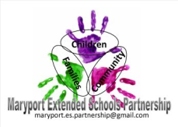
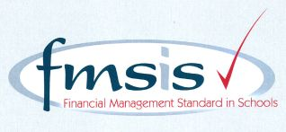
Big enough for opportunity
Small enough to care

CROSSCANONBY ST JOHN'S CofE PRIMARY SCHOOL

Mrs A Pitcher Telephone: 01900 812326
Executive Headteacher Fax: 01900 816420
Garborough Close e-mail: head@crosscanonby.cumbria.sch.uk
Crosby www.crosscanonby.cumbria.sch.uk

MARYPORT

Cumbria CA15 6RX

Dear Parents/Guardians,

For your information we have outlined below some of the topics that will be covered this term in Year 4. We have already made a good start to our studies and we feel sure that you will make every effort to assist and encourage your child as this term progresses.

ENGLISH:

- Diary entries
- Descriptive writing
- Letters
- Story writing – imaginative
- explanatory descriptions
- News reports
- Reasoned arguments
- Instructions
- Poetry

- SPaG (Spelling, Grammar and Punctuation):

- Writing dialogue
- Writing in the first and third person.
- Past and present tenses of verbs.
- Metaphors
- Fronted adverbials
- Conjunctions
- Editing and improving work.

SCIENCE:
- Light
- Forces and magnets

MATHEMATICS:

- Number and place value to 10 000
- Addition and subtraction
- Multiplication and division
- Rounding numbers to the nearest 10,100,1000
- Calculate area
- Roman Numerals

HISTORY:

- Significant Monarchs – Tudors.

GEOGRAPHY:

- All around the world – Investigating places in different hemispheres and time zones.

ART/DESIGN AND TECHNOLOGY

- Autumn Art
- Investigating ,designing and making bread.

RE:
- What kind of world did Jesus want.
- Incarnation – the importance of light in the Christmas story.

PE:
- Modified team games – hand eye co ordination
- Tag rugby
- Modified games attacking and defending.
- Handball and basket ball

COMPUTING:

- Online Safety
- Spreadsheets

MUSIC

PSHE

- Being me in my world
- Celebrating differences

FRENCH

- All around the town
- On the move

