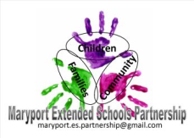
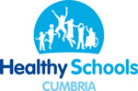
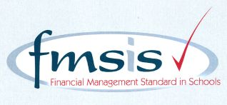
Big enough for opportunity
Small enough to care
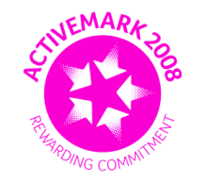

CROSSCANONBY ST JOHN'S CofE PRIMARY SCHOOL

Mrs A Pitcher Telephone: 01900 812326
Executive Headteacher Fax: 01900 816420
Garborough Close e-mail: head@crosscanonby.cumbria.sch.uk
Crosby www.crosscanonby.cumbria.sch.uk

MARYPORT

Cumbria CA15 6RX

Dear Parents/Guardians,

For your information we have outlined below some of the topics that will be covered this term in Year 2. We have already made a good start to our studies and we feel sure that you will make every effort to assist and encourage your child as this term progresses.

ENGLISH:
- Planning a story
- Writing stories
- Editing and improving writing
- Reading Comprehension
- Vocabulary for narrative writing
- Create a setting description
- Planning a piece of writing
- Finding and collating information
- Use of group discussion and oral rehearsal
- To re-draft an information text
- Ordering and sequencing a story
- Characters’ feelings and thoughts
- Developing writing stamina

SPELLING,PUNCTUATION and GRAMMAR

- Present and past tenses
- Expanded noun phrases
- Adjectives
- Using new vocabulary
- Speech punctuation
- Using the past tense
- Subordinating and co-ordinating conjunctions
SCIENCE:

- Animals, including humans
- Everyday materials
Chemistry – materials their properties and their uses. Testing and changing properties .

MATHEMATICS:
- Money
- Multiplication and Division
- Length and Height
- Mass, Capacity and Temperature

HISTORY:
- How has transport changed over time?

GEOGRAPHY:
- Why are some places in the world always hot and others always cold?

ART and DESIGN AND TECHNOLOGY:
- What is a ‘still life’ anyway? – DRAWING
- How can we put on a finger puppet show? - MATERIALS/TEXTILES

- RE:
- What do sacred writings teach us about leaders?
UNDERSTANDING CHRISTIANITY: People of God
- Resurrection
- UNDERSTANDING CHRISTIANITY: Salvation

PE:
- Dance
- Gymnastics

COMPUTING:

- Expressive arts and design
- Maze Design

MUSIC

- Pitch and dynamics

PSHE
- Dreams and Goals
- Healthy Me

