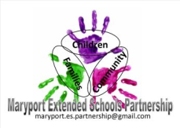
Big enough for opportunity
Small enough to care
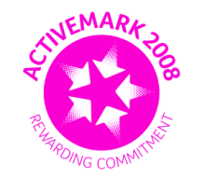

CROSSCANONBY ST JOHN'S CofE PRIMARY SCHOOL

Mrs A Pitcher Telephone: 01900 812326
Executive Headteacher Fax: 01900 816420
Garborough Close e-mail: head@crosscanonby.cumbria.sch.uk
Crosby www.crosscanonby.cumbria.sch.uk

MARYPORT

Cumbria CA15 6RX

Dear Parents/Guardians,

For your information we have outlined below some of the topics that will be covered this term in Year 2. We have already made a good start to our studies and we feel sure that you will make every effort to assist and encourage your child as this term progresses.

ENGLISH:
- Planning a story
- Writing stories
- Editing and improving writing
- Reading Comprehension
- Vocabulary for narrative writing
- Create a setting description
- Planning a piece of writing
- Investigating the structure and composition of a fact file
- Finding and collating information
- Use of group discussion and oral rehearsal
- To re-draft an information text
- Ordering and sequencing a story
- Characters’ feelings and thoughts

SPELLING,PUNCTUATION and GRAMMAR

- Present and past tenses
- Expanded noun phrases
- Adjectives
- Using new vocabulary
- Speech punctuation
- Using the past tense
- Subordinating and co-ordinating conjunctions
SCIENCE:

- Living Things and Their Habitats
- Plants
Chemistry – materials their properties and their uses. Testing and changing properties .

MATHEMATICS:

- Place Value
- Addition
- Subtraction
- 2D and 3D Shape

HISTORY:
- The Gunpowder Plot

GEOGRAPHY:
- Mapping Skills – linking to our local area

ART and DESIGN AND TECHNOLOGY:
- Colour Mixing – A Study of Kandinski
- Designing and making clothes for a hot/cold holiday

RE:
- What is the good news that Jesus brings?
UNDERSTANDING CHRISTIANITY: Gospel
- ‘Celebrations’ – How and why do Christians celebrate Christmas?
UNDERSTANDING CHRISTIANITY: Incarnation

PE:
- Modified games- hand eye co ordination, attacking and defending.
- Modified games- Batting and fielding
- Tag rugby

COMPUTING:

- Online Safety
- Coding

MUSIC

- Festivals
- Living things
- Pitch and dynamics

PSHE
- Being Me In My World
- Celebrating Difference

