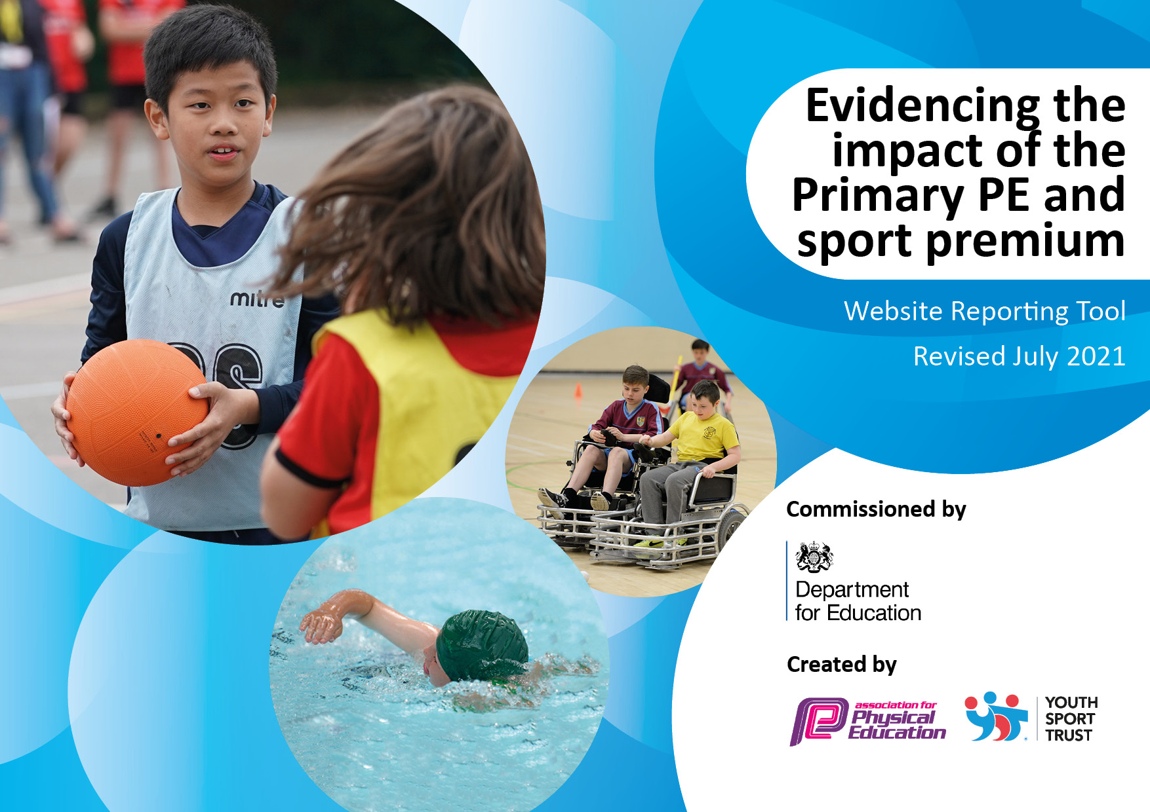
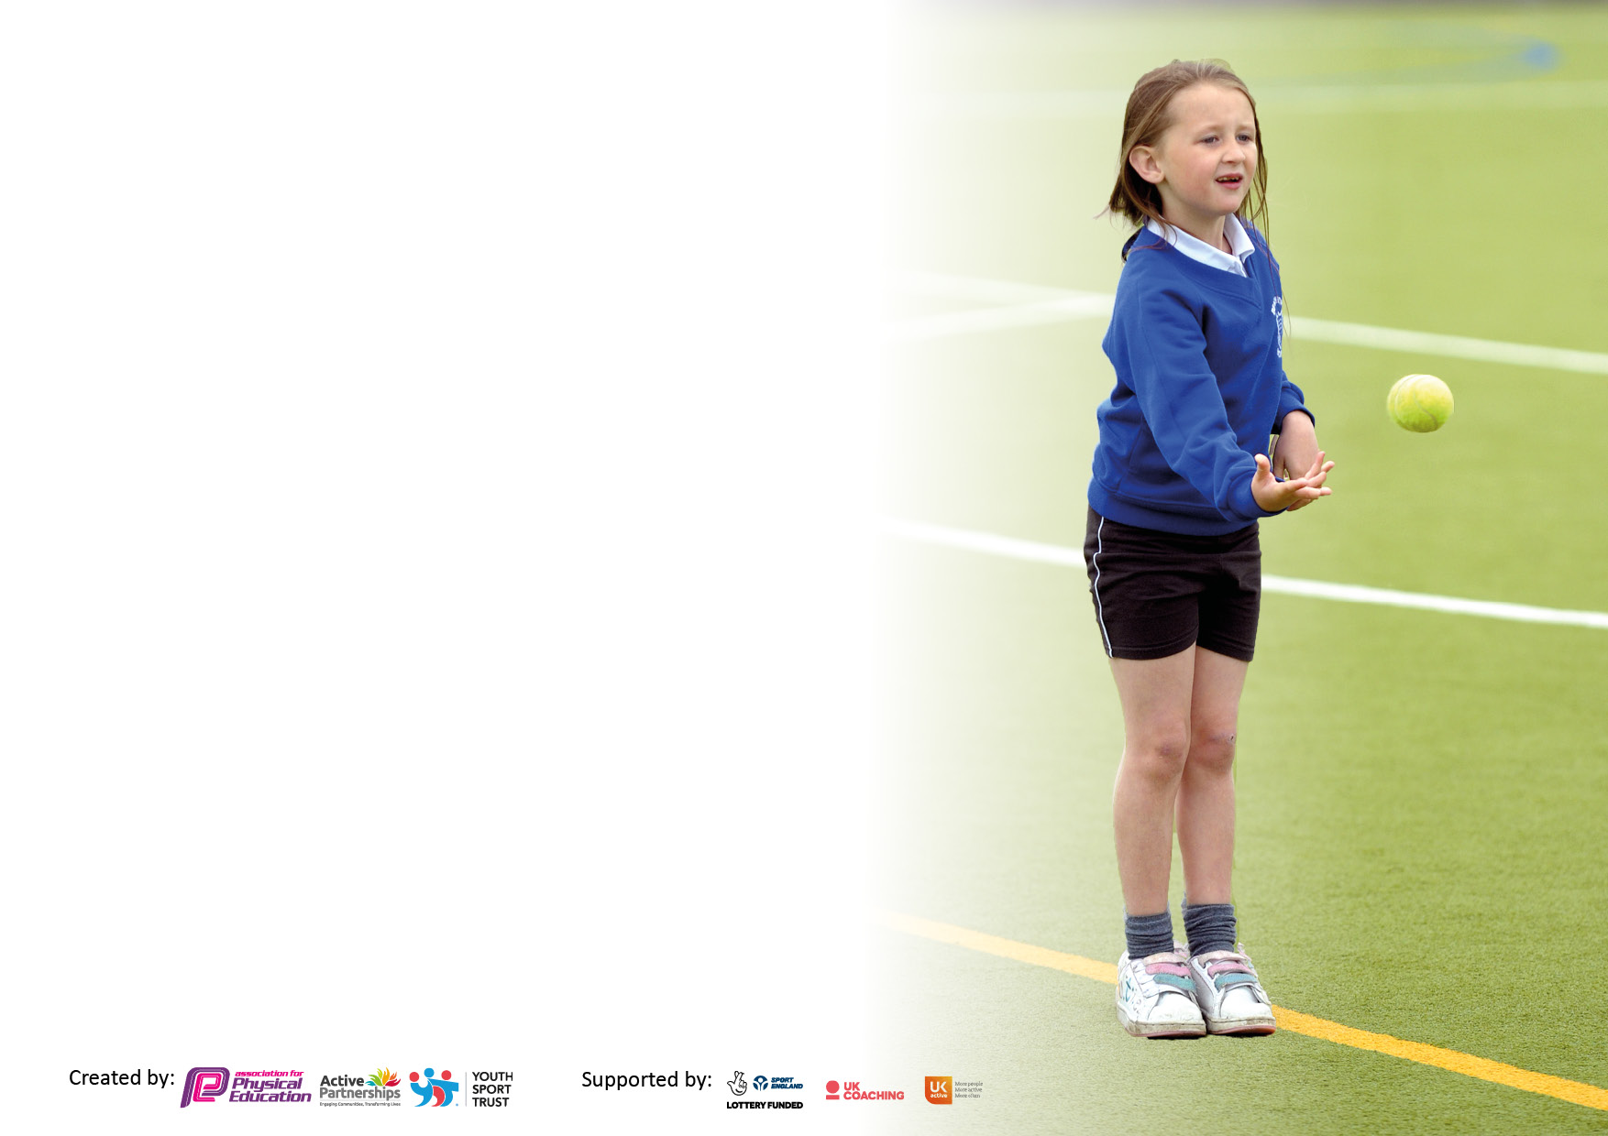

It is important that your grant is used effectively and based on school need. The Education Inspection Framework makes clear there will be a focus on ‘whether leaders and those responsible for governors all understand their respective roles and perform these in a way that enhances the effectiveness of the school’.

Under the Quality of Education Ofsted inspectors consider:
Intent - Curriculum design, coverage and appropriateness
Implementation - Curriculum delivery, Teaching (pedagogy) and Assessment
Impact - Attainment and progress

To assist schools with common transferable language this template has been developed to utilise the same three headings which should make your plans easily transferable between working documents.

Schools must use the funding to make additional and sustainable improvements to the quality of Physical Education, School Sport and Physical Activity (PESSPA) they offer. This means that you should use the Primary PE and sport premium to:

- Develop or add to the PESSPA activities that your school already offer
- Build capacity and capability within the school to ensure that improvements made now will benefit pupils joining the school in future years
- The Primary PE and sport premium should not be used to fund capital spend projects; the school’s budget should fund these.

Pleasevisitgov.ukfortherevisedDfEguidanceincludingthe5keyindicatorsacrosswhichschoolsshoulddemonstrate animprovement.Thisdocumentwillhelpyoutoreviewyourprovisionandtoreportyourspend.DfEencouragesschools to use this template as an effective way of meeting the reporting requirements of the Primary PE and sport premium.

We recommend you start by reflecting on the impact of current provision and reviewing the previous spend.

Schools are required to publish details of how they spend this funding, including any under-spend from 2019/2020, as well as on the impact it has on pupils’ PE and sport participation and attainment. All funding must be spent by 31st July 2022.

We recommend regularly updating the table and publishing it on your website throughout the year. This evidences your ongoing self-evaluation of how you are using the funding to secure maximum, sustainable impact. Final copy must be posted on your website by the end of the academic year and no later than the 31st July 2021. To see an example of how to complete the table please click HERE.
Created by: Supported by:

Details with regard to funding
Please complete the table below.

Total amount carried over from 2019/20 | £0
Total amount allocated for 2020/21 | £7032
How much (if any) do you intend to carry over from this total fund into 2021/22? | £1548 (£1925 allocated for residential outdoor visit)
Total amount allocated for 2021/22 | £14110
Total amount of funding for 2021/22. To be spent and reported on by 31st July 2022. | £15658
Swimming Data
Please report on your Swimming Data below.

Meeting national curriculum requirements for swimming and water safety.  N.B. Complete this section to your best ability. For example you might have practised safe self-rescue techniques on dry land which you can then transfer to the pool when school swimming restarts.  Due to exceptional circumstances priority should be given to ensuring that pupils can perform safe self rescue even if they do not fully meet the first two requirements of the NC programme of study | Pupils in Year 4/5/6 took part in swimming sessions at a local pool- 5 two hour sessions were provided.
What percentage of your current Year 6 cohort swim competently, confidently and proficiently over a distance of at least 25 metres?  N.B. Even though your pupils may swim in another year please report on their attainment on leaving primary school at the end of the summer term 2022.  Please see note above | 67%
What percentage of your current Year 6 cohort use a range of strokes effectively [for example, front crawl, backstroke and breaststroke]?  Please see note above | 67%
What percentage of your current Year 6 cohort perform safe self-rescue in different water-based situations? | 67%
Schools can choose to use the Primary PE and sport premium to provide additional provision for swimming but this must be for activity over and above the national curriculum requirements. Have you used it in this way? | No

Action Plan and Budget Tracking
Capture your intended annual spend against the 5 key indicators. Clarify the success criteria and evidence of impact that you intend to measure to evaluate for pupils today and for the future.

Academic Year: 2021/22 | Total fund allocated:14110 | Date Updated:31/7/2022
Key indicator 1: The engagement of all pupils in regular physical activity – Chief Medical Officers guidelines recommend that primary school pupils undertake at least 30 minutes of physical activity a day in school |  |  |  | Percentage of total allocation:
 |  |  |  | %
Intent | Implementation |  | Impact
Your school focus should be clear what you want the pupils to know and be able to do and about  what they need to learn and to  consolidate through practice: | Make sure your actions to achieve are linked to your intentions: | Funding allocated: | Evidence of impact: what do pupils now know and what can they now do? What has changed?: | Sustainability and suggested next steps:
To improve participation of SEND pupils in curriculum sessions.  All children to become proficient swimmers. | Additional adult support in PE lessons for pupils who struggle to engage with the activities.  2 hours of timetabled lessons each week for every pupil, allowing pupils to develop themselves as a whole person, build a sound knowledge of basic skills and to build a positive relationship with physical health.  Swim sessions for Yr4 upwards. | £4175 | Targeted pupils more involved and able to participate in not just individual activities but also as part of a larger group and able to take part in some competitive intra and inter school competitions. Pupils able to talk about their enjoyment of the sports.  Children will become more active each day, improving their health and wellbeing.  Children will be aware of the benefits of physical activity.  Children will have a good knowledge of basic skills. | To continue with strategy for SEND pupils and to have a graduated approach so they can become involved more independently- work with coaches on this approach.  Continue to offer swim sessions to KS2 pupils to build on skills previously learnt.
Key indicator 2: The profile of PESSPA being raised across the school as a tool for whole school improvement |  |  |  | Percentage of total allocation:
 |  |  |  | %
Intent | Implementation |  | Impact
Your school focus should be clear what you want the pupils to know and be able to do and about  what they need to learn and to  consolidate through practice: | Make sure your actions to achieve are linked to your intentions: | Funding allocated: | Evidence of impact: what do pupils now know and what can they now do? What has changed?: | Sustainability and suggested next steps:
To use PSHE lessons to promote health lifestyles.  To celebrate achievements by children in PE.  To update the PE display board in school to share events, information and to celebrate sporting achievements.  Inspire children to participate in PE.  To advertise sports clubs in the local area. | Weekly lessons looking at how participation in exercise impacts on learning and mental and physical health.  Weekly celebration assemblies and pupils given time to talk about and celebrate their sporting achievements out of school.  Invite athletes into school. | £1795 | Pupils can talk about what constitutes healthy lifestyles.  Pupils confident at showing others what they have achieved. Pupils participating in local clubs. | Continue to work with staff from local clubs and to increase range of after school clubs.  Invite club members/coaches in to talk to pupils and to promote clubs.

Key indicator 3: Increased confidence, knowledge and skills of all staff in teaching PE and sport |  |  |  | Percentage of total allocation:
 |  |  |  | %
Intent | Implementation |  | Impact
Your school focus should be clear | Make sure your actions to | Funding | Evidence of impact: what do | Sustainability and suggested
what you want the pupils to know | achieve are linked to your | allocated: | pupils now know and what | next steps:
and be able to do and about | intentions: |  | can they now do? What has
what they need to learn and to |  |  | changed?:
consolidate through practice:
To develop staff competency in tennis and cricket so that they can provide additional coaching to pupils. Pupils to develop skills and strategies. To develop subject leadership in PE.  Staff will be confident to support children with their well-being and mental health. | Staff to work alongside coaching staff and coaches to coach teachers.  Staff to access NC resources and training.  The use of Allerdale sports partnership. Staff will assist specialist coaches and share knowledge with staff.  Jigsaw resources. | £2675 | Staff developed more confidence in delivering some aspects of PE, but time frames limited due to staff absences. | To continue to develop this due to staff absences and reduced opportunities because of this. Staff to share knowledge with others.
Key indicator 4: Broader experience of a range of sports and activities offered to all pupils |  |  |  | Percentage of total allocation:
Intent | Implementation |  | Impact
Your school focus should be clear | Make sure your actions to | Funding | Evidence of impact: what do | Sustainability and suggested
what you want the pupils to know | achieve are linked to your | allocated: | pupils now know and what | next steps:
and be able to do and about | intentions: |  | can they now do? What has
what they need to learn and to |  |  | changed?:
consolidate through practice:
Improved confidence in taking part in more adventurous activities. To offer a range of activities to develop resilience and team building skills. To improve water confidence.  To develop understanding of how disability does not impact on ability to participate in sports. | Outdoor and adventurous activities led by qualified staff during residential visit.  Invite wheelchair basketball team into school. | £2475 | Pupils reported that they felt more able to attempt difficult and challenging activities. They said they had tested themselves and felt able to participate safely and confidently in water sports (canoeing) and using a zip line. They developed team work skills through having to traverse challenging obstacles together.  Wheelchair basket ball session- all pupils engaged and enjoyed the session- able to talk about how competitive they could be. | To build on this further by accessing forest school activities and further outdoor and disabled sports facilities and resources.  Re-introduce young leaders playtime sessions.

Key indicator 5: Increased participation in competitive sport |  |  |  | Percentage of total allocation:
 |  |  |  | %
Intent | Implementation |  | Impact
Your school focus should be clear | Make sure your actions to | Funding | Evidence of impact: what do | Sustainability and suggested
what you want the pupils to know | achieve are linked to your | allocated: | pupils now know and what | next steps:
and be able to do and about | intentions: |  | can they now do? What has
what they need to learn and to |  |  | changed?:
consolidate through practice:
To give children an opportunity to develop a better sense of competition - either competing against themselves and/or others in a recognised environment (PE lessons for example) or against an unrecognised opponent. Increased exposure to competition will allow pupils to better develop their relationship with physical health and its ability to build traits such as humility, cooperation, passion, pride and competitiveness. | Staff will plan opportunities for children to use newly acquired skills in competitive games/activities during PE lessons.  We will take part in a variety of tournaments at school both inter and intra.  We will aim to attend at least one tournament per term or half term.  Children will get opportunity to represent their school.  Expose children to real life athletes to inspire children to join in with sports. | £500 | Children will work as part of a team.  Children will represent their school  Children will compete in a inter/intra competition in the disciplines.  Some competitions not attended due to staff absence and/or pupil absence. | Increased access to competitions through local secondary school competitions as well as cluster schools.  Informal joint activities between us and Boltons pupils.

Signed off by
Head Teacher: | Amanda Pitcher
Date: | 26/7/2022
Subject Leader: | Kelly Bowe
Date: | 27/7/2022
Governor: | L McDonald
Date: | 28/7/2022

